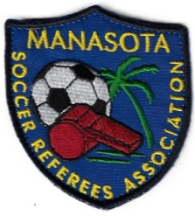

MSRA
Board Candidate Personal Fact Sheet

Candidate Name, Address, Email and Phone:

What position are you running for:

How long have you been a soccer referee?

Professional/Employment Information:

Have you previously served as a board member for any organization(s)?

If so, please list the organization(s), position and years served.

Please describe why you would like to be a member of the board.

What committee would you participate in to advance the organization (Evaluation Committee, Recommendations Committee, Grievance Committee, or Education and Training Committee)?

Why are you interested in this committee?

